Name _____________________________________________________________________

Homework for Week 25: March 9, 2020

Directions: Pick at least four of the following activities to complete at home this week. If an activity is marked with this symbol ****, you must do that activity. If you choose not to do some of the worksheet activities, please remove the papers before handing in your packet of completed work at the end of the week. All activities are due Friday.

****1. March 19, the first day of spring, is almost here! Hurrah! Look through magazines, newspaper advertisements, and catalogs for pictures of things which remind you of spring. Cut a piece of poster board into the shape of a large flower. Glue your spring pictures on this flower. Your big, lovely, bright, colorful flowers will be displayed in the windows of Room 104! If your flower fits into your homework folder, it is not big enough. Here are some flowers from last year:

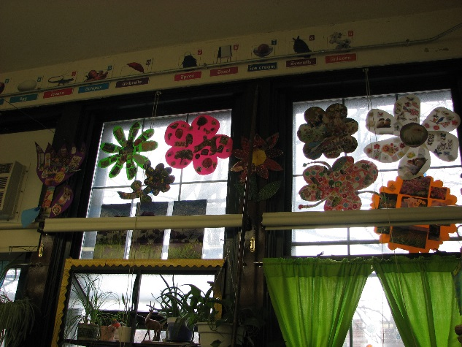

____2.This week’s spelling unit focuses on the r-controlled vowel sound /âr/. It may be written air, ear, are, ere, or eir! Complete two or more of the Unit 22 Extra Pattern Practice worksheets.

____3. Complete another two or more /âr/ spelling pattern worksheets.

____4. There are many kinds of cycles in science. We have studied animal life cycles, plant life cycles, and the water cycle. Did you know that there is a rock cycle? Complete the rock cycle wheel to see how sedimentary, igneous, and metamorphic rocks are connected!

____5. Randolph Caldecott, the illustrator for whom the Caldecott Medal for picture books is named, was born in March. Read a book that has won the Caldecott Medal. You may use this book for your 20 minutes of reading tonight. Write a paragraph describing the illustrations. Be sure to include a topic sentence and at least four other sentences. Your last sentence should be a feeling sentence describing your reaction to the illustrations.

____6. We learn about Asia in March. Complete the word search about Asian countries and animals.

____7. Rewrite the sentences correctly on the “Week Twenty-Five” paper. Use proofreading symbols on the printed sentences before you rewrite them.

____8. Come back to school on Thursday between 6:00 and 8:00 for Family Wellness Night!

____9. March is Women’s History Month. Did you know that in the 1800s, some women wore clothing that weighed between 20 and 40 pounds? Place your backpack on a bathroom scale. Add books to it until the scale reads 20 pounds. Lift the bag and walk around your home. Imagine how difficult it would have been to move if you had to carry that much weight in clothing! How much do you think a pair of your pants and one of your shirts weighs? Take one of your pants and a shirt and place them on the scale. Compare the weight of women’s clothing in the 1800s to what is worn today.

____10. Practice your D’Nealian handwriting on the lowercase q and v pages. Pay attention to the placement of the letters on the paper. As always, start at the top and pull down.

