EnchantedLearning.com  Label Earthworm  External Anatomy  Using the definitions listed below, label the earthworm diagram. | Name_______________________

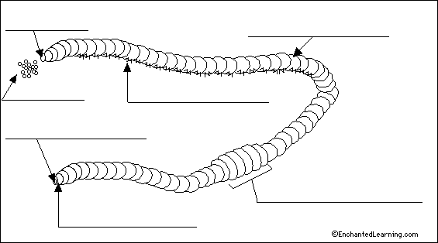
anus - the opening at the end of a worm through which waste exits. The last segment, which contains the anus, is called the periproct.
castings - the waste produced by an earthworm.
clitellum - the enlarged part of the earthworm that contains the reproductive parts; it produces the eggs. The clitellum is about one third of the way down the body from the head.
mouth - The cavity at the front of the earthworm through which the worm eats. The first segment, which contains the mouth, is called the peristomium.
paired setae - tiny bristles (or hairs) that occur in pairs on most segments; setae anchor the stationary segments as the worm moves forward and help sense the environment.
prostomium - a tiny flap in front of the mouth.
segment - the earthworm's body is divided into over a hundred rings, called segments.

