Diary of a Worm Sequencing

Cut out the events from Diary of a Worm and glue them in the order they happened.

April
10
After a rain,
the worm spent
the day on the

sidewalk.

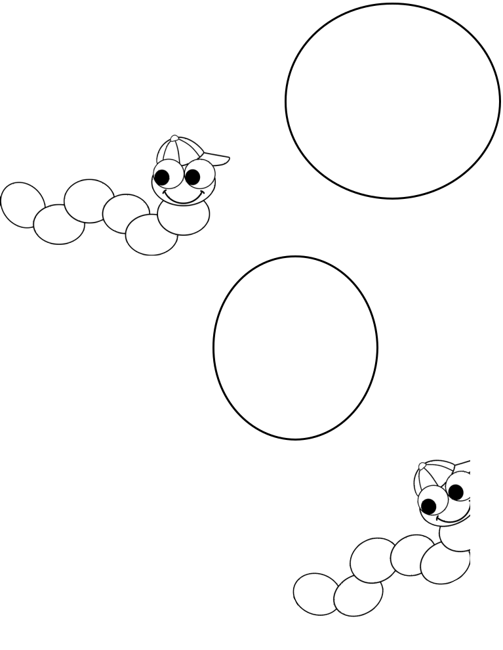
April
20
The worm
scared some
children

in the park.

April
15
The worm
forgot his
homework.

May
28
The worm
went to a
school dance.

June
5
The worm
ate macaroni

for dinner.

March
29
The worm tried
to teach spider

to dig

Diary of a Worm Sequencing

